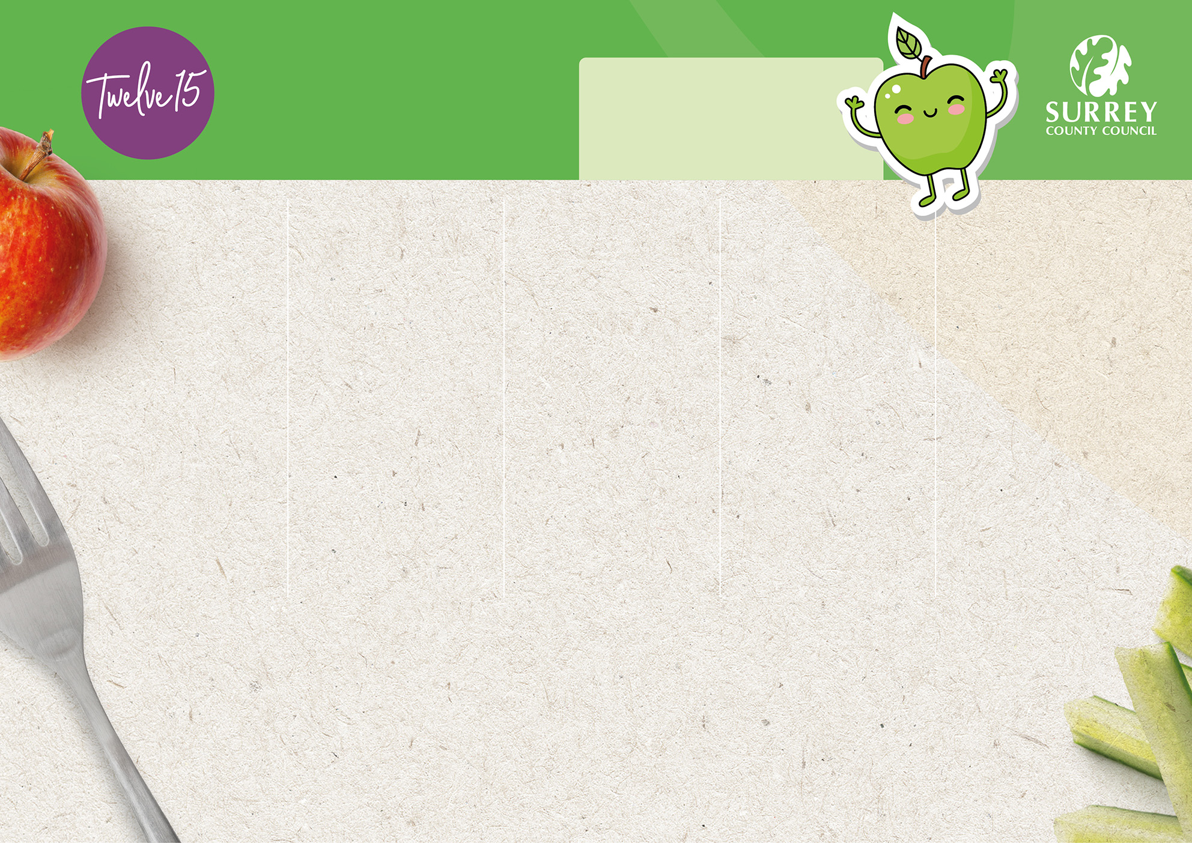

**Weeks Starting:**21st April, 12th May,   
9th June, 30th June,   
21st July, 15th September   
and 6th October

**Week 1**

Spring/Summer 2025 Menu

**Monday**

**Friday**

**Thursday**

**Wednesday**

**Tuesday**



**Option 1**

**Option 1**

**Option 1**

**Option 1**

**Option 1**

Fish Fingers with Oven Chips

Beef Pasta Bolognese

Roast Chicken with Roast Potatoes and Gravy

Chicken and Five Veg Meatballs in Tomato Sauce with Couscous

Cheese and   
Tomato Pizza with Potato Tots

Vegetarian meal


**Option 2**

**Option 2**

**Option 2**

**Option 2**

**Option 2**

Cheese and Tomato Swirl with Oven Chips

Vegan Pasta Bolognese

Roasted Vegetable Parcel with Roast Potatoes and Gravy

Veggie Meatballs in Tomato Sauce with Couscous

Butternut Squash Mac ‘n’ Cheese

**Option 3**

**Option 3**

**Option 3**

**Option 3**

**Option 3**

Tuna Wrap

Cheese Wrap

Ham Wrap



Jacket Potato and Baked Beans

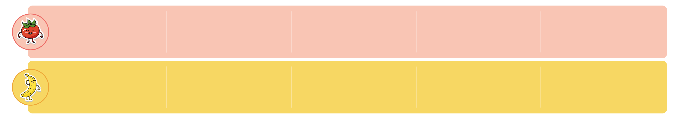

**Sides:**

**Sides:**

**Sides:**

**Sides:**

**Sides:**

Seasonal Vegetables, & Fresh Bread

Seasonal Vegetables, & Fresh Bread

Seasonal Vegetables, Salad Bar   
& Fresh Bread

Seasonal Vegetables, Salad Bar   
& Fresh Bread

Seasonal Vegetables, Salad Bar   
& Fresh Bread



**Dessert:**

**Dessert:**

**Dessert:**

**:**

**Dessert:**

**:**

**Dessert:**

**:**

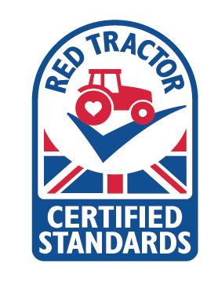

Fresh Dairy   
Yoghurt

Peaches with   
Vanilla Yoghurt

Apple Sponge   
with Custard

Vanilla  
Ice Cream

Chocolate  
Cookie

Vegetarian

Contains a minimum of 50% fruit



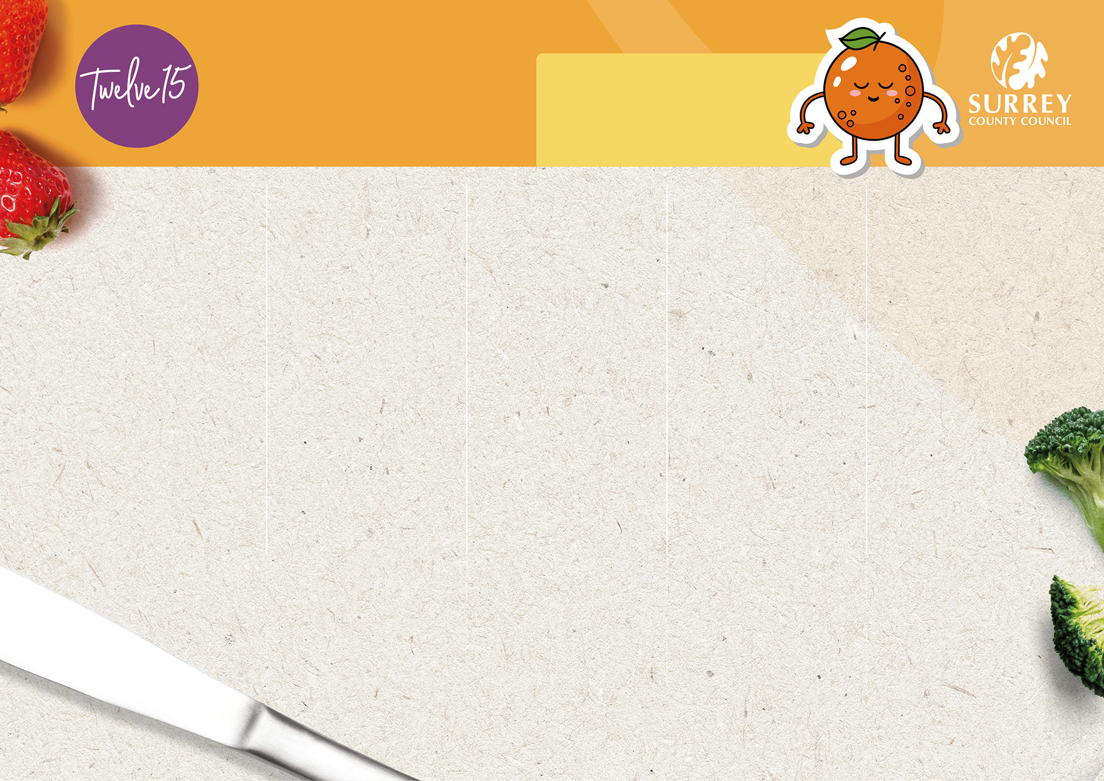

**Weeks Starting:**28th April, 19th May, 16th June,   
7th July, 1st September,   
22nd September  
and 13th October

**Week 2**

Spring/Summer 2025 Menu

**Friday**

**Thursday**

**Wednesday**

**Tuesday**

**Monday**



**Option 1**

**Option 1**

**Option 1**

**Option 1**

**Option 1**

Cheese and   
Tomato Pasta Bake

Chicken Burger with Potato Tots

Roast Pork with Roast Potatoes and Gravy

Creamy Chicken and Sweetcorn with Rice

Harry Ramsden’s Fish with Oven Chips



**Option 2**

**Option 2**

**Option 2**

**Option 2**

**Option 2**

Veggie   
Burrito

Glamorgan Sausage with Roast Potatoes and Gravy

Southern Style Quorn Burger   
with Potato Tots

Veggie Sausage and Tomato Roll with Potato Tots

Vegetable Fingers with Oven Chips



Tuna Wrap

Cheese Wrap

Ham Wrap

**Option 3**

**Option 3**

**Option 3**

**Option 3**

**Option 3**

Jacket Potato and Baked Beans



**Sides:**

**Sides:**

**Sides:**

**Sides:**

**Sides:**

Seasonal Vegetables, & Fresh Bread

Seasonal Vegetables, & Fresh Bread

Seasonal Vegetables, Salad Bar   
& Fresh Bread

Seasonal Vegetables, Salad Bar   
& Fresh Bread

Seasonal Vegetables, Salad Bar   
& Fresh Bread



**Dessert:**

**:**

**Dessert:**

**:**

**Dessert:**

**Dessert:**

**:**

**Dessert:**



Frozen Yoghurt   
with Mango

Fruit   
Jelly

Vanilla Sponge   
with Custard

Chocolate   
Mousse

Shortbread Biscuit with Fresh Fruit Slices

Vegetarian

Contains a minimum of 50% fruit



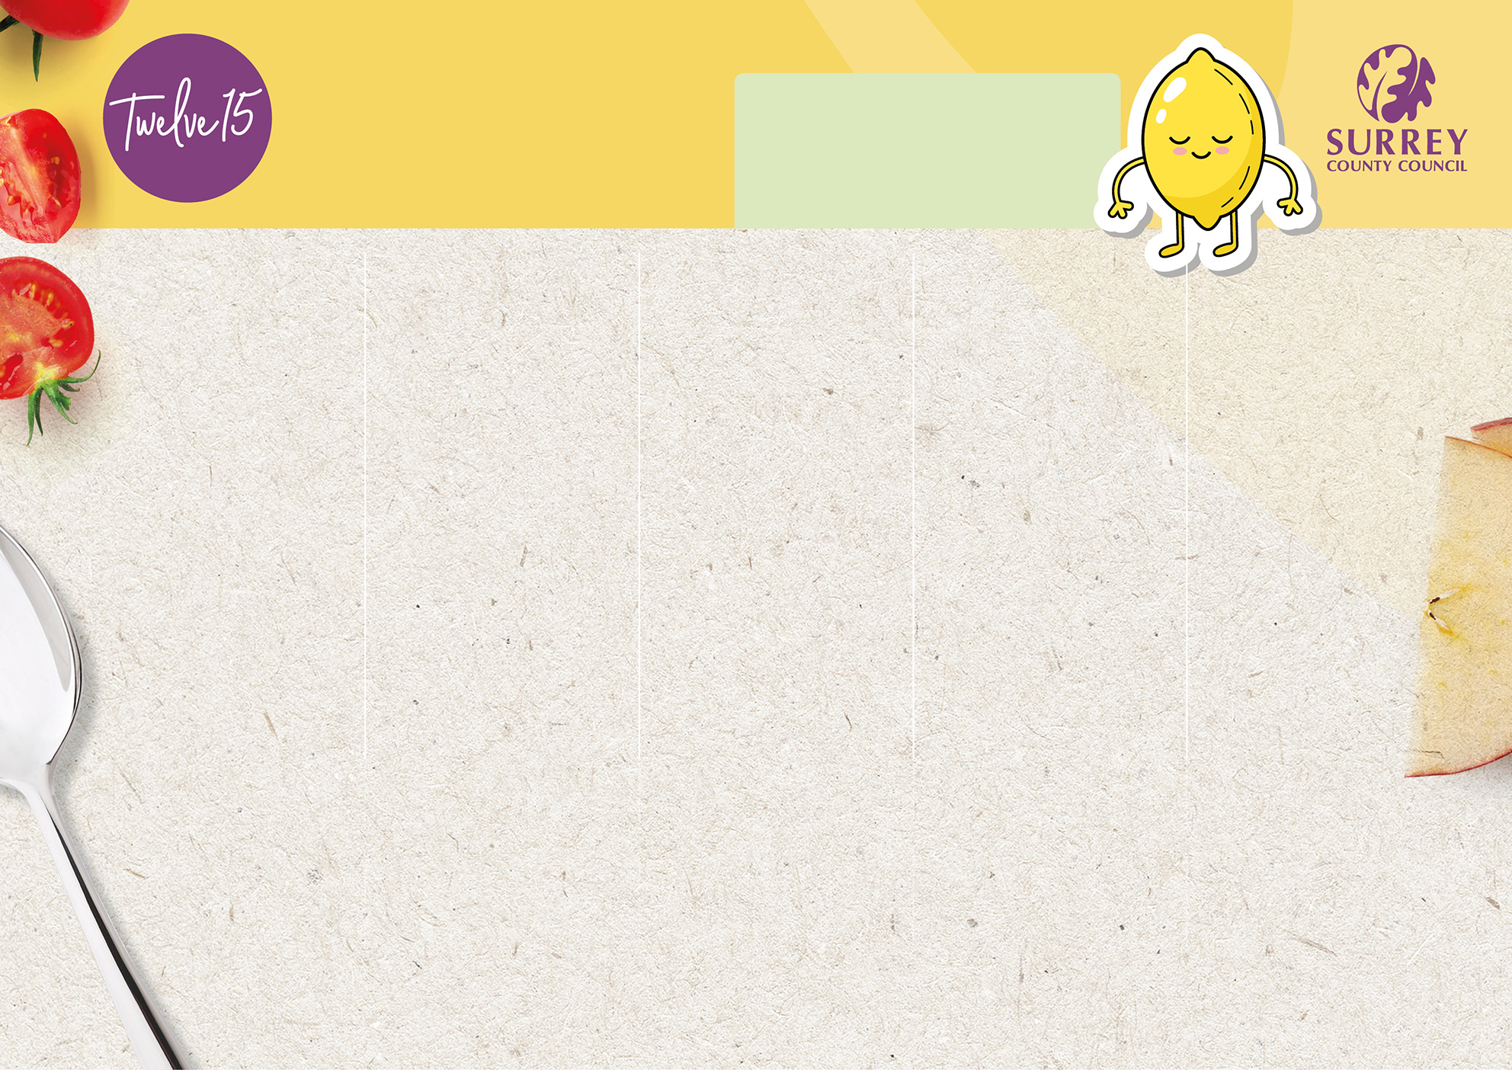

**Weeks Starting:**5th May, 2nd June, 23rd June,  
14th July, 8th September,  
29th September  
and 20th October

**Week 3**

50% fruit
50% fruit


Jacket Potato and Baked Beans

**Dessert:**

**Dessert:**

**Dessert:**

**:**

**Dessert:**

**:**

**Dessert:**

**:**

Raspberry Ripple  
Ice Cream Roll

Vegetarian

Contains a minimum of 50% fruit



**Sides:**

**Sides:**

**Sides:**

**Sides:**

**Sides:**

**Friday**

**Thursday**

**Wednesday**

**Tuesday**

**Monday**

Spring/Summer 2025 Menu

Lemon   
Shortbread

Pear Sponge  
with Custard

Fresh Dairy   
Yoghurt

Fresh Fruit Salad  
with Vanilla Yoghurt

**Option 1**

**Option 2**

**Option 2**

**Option 2**

**Option 2**

**Option 2**

Roast Chicken   
with Roast Potatoes and Gravy

Veggie   
Dippers with   
Oven Chips

Southern Style Quorn Katsu Curry with Rice

Vegan Sausage Cutlet with Roast Potatoes and Gravy

Quorn Sausage with Creamed Potato and Gravy

Mediterranean  
Vegetable Pasta

Fish Fingers with Oven Chips

Chicken Katsu   
Curry with Rice

Pork Sausages with Creamed Potato and Gravy

Veggie Feast Pizza with   
Potato Tots

**Option 3**

**Option 3**

**Option 3**

**Option 3**

**Option 3**

Tuna Wrap

Cheese Wrap

Ham Wrap

**Option 1**

**Option 1**

**Option 1**

**Option 1**

Seasonal Vegetables, & Fresh Bread

Seasonal Vegetables, & Fresh Bread

Seasonal Vegetables, Salad Bar   
& Fresh Bread

Seasonal Vegetables, Salad Bar   
& Fresh Bread

Seasonal Vegetables, Salad Bar   
& Fresh Bread